🔹 Icon | Concept / Term | English (Definition / Concept / Rule) | Arabic Translation
⚛️ | Atoms & matter | Atoms are the foundation of our sensations. | الذرات هي أساس إحساساتنا بالمادة.
🧱 | Matter composition | Atoms compose matter. | الذرات تُكوّن المادة.
🔍 | Atom | An atom is the smallest identifiable unit of an element. | الذرة هي أصغر وحدة يمكن التعرف عليها للعنصر.
🧪 | Element | An element is a substance that cannot be broken down into simpler substances. | العنصر مادة لا يمكن تحليلها إلى مواد أبسط.
🧩 | Compound | A compound is a substance formed when atoms of different elements combine in fixed ratios. | المركب مادة تنتج من اتحاد ذرات عناصر مختلفة بنِسَب ثابتة.
🧺 | Mixture | A mixture is a physical combination of substances that retain their individual properties. | المخلوط هو اتحاد فيزيائي لمواد تحتفظ بخواصها الأصلية.
🌊 | Example (compound) | Typical seaside rocks are composed of silicates, compounds of silicon and oxygen atoms. | تتكون الصخور الشاطئية عادة من السيليكات، وهي مركبات من السيليكون والأكسجين.
🌬️ | Example (mixture) | Seaside air contains nitrogen and oxygen molecules. | يحتوي هواء الشاطئ على جزيئات النيتروجين والأكسجين.
🧪 | Amines | Seaside air may contain substances called amines. | قد يحتوي هواء الشاطئ على مواد تُسمى الأمينات.
🐟 | Triethylamine | Triethylamine is emitted by decaying fish and contributes to the fishy smell. | يُطلق ثلاثي إيثيل أمين من تحلل الأسماك ويساهم في الرائحة السمكية.
🏔️ | Atomic size (analogy) | If every atom in a pebble were the size of the pebble, it would be larger than Mount Everest. | لو كان كل ذرة بحجم الحصاة نفسها لأصبحت أكبر من جبل إيفرست.
🌍 | Natural elements | There are about 91 different elements in nature. | يوجد حوالي 91 عنصرًا مختلفًا في الطبيعة.
🧫 | Synthetic elements | Scientists have made about 20 synthetic elements not found in nature. | تم تصنيع حوالي 20 عنصرًا صناعيًا غير موجود في الطبيعة.
📜 | Early atomic idea | Democritus and Leucippus proposed that matter is made of tiny, indestructible particles (atomos). | اقترح ديموقريطس ولوكيوس أن المادة مكوّنة من جسيمات صغيرة غير قابلة للتدمير (أتوموس).
🧠 | Dalton theory (1) | Each element is composed of tiny, indestructible particles called atoms. | كل عنصر مكوَّن من جسيمات صغيرة غير قابلة للتدمير تُسمى ذرات.
⚖️ | Dalton theory (2) | All atoms of a given element have the same mass and properties. | جميع ذرات العنصر الواحد لها نفس الكتلة والخصائص.
🔢 | Dalton theory (3) | Atoms combine in simple, whole-number ratios to form compounds. | تتحد الذرات بنِسَب عددية صحيحة بسيطة لتكوين المركبات.
⚾ | Relative mass | A proton is nearly 2000 times as massive as an electron. | البروتون كتلته تقارب 2000 ضعف كتلة الإلكترون.
⚖️ | Proton & neutron | Protons and neutrons have similar masses. | للبروتونات والنيوترونات كتل متقاربة.
🌾 | Electron mass | Electrons have almost negligible mass. | كتلة الإلكترونات مهملة تقريبًا.
⚡ | Electrical charge | Electrical charge is a fundamental property of protons and electrons. | الشحنة الكهربائية خاصية أساسية للبروتونات والإلكترونات.
➕➖ | Attraction | Positive and negative charges attract each other. | الشحنات الموجبة والسالبة تتجاذب.
➕➕ | Repulsion | Like charges repel each other. | الشحنات المتشابهة تتنافر.
0️⃣ | Neutral atom | A proton and an electron together are charge-neutral. | البروتون والإلكترون معًا يعطيان جسيمًا متعادل الشحنة.
🧬 | Element identity | Elements are defined by their number of protons. | تُعرَّف العناصر بعدد البروتونات.
🔢 | Atomic number (Z) | The atomic number (Z) is the number of protons in the nucleus. | العدد الذري (Z) هو عدد البروتونات في النواة.
🧾 | Periodic table | The periodic table lists elements according to increasing atomic number. | الجدول الدوري يرتب العناصر حسب تزايد العدد الذري.
🔤 | Symbols (English) | Most chemical symbols are based on English names (C, Br). | معظم الرموز الكيميائية مأخوذة من الأسماء الإنجليزية.
🏛️ | Symbols (Latin) | Some symbols come from Latin (Na, K, Fe, Pb). | بعض الرموز مأخوذة من اللغة اللاتينية.
🧠 | Periodic law | Similar properties recur in a regular pattern (periodic law). | تتكرر الخصائص المتشابهة بنمط منتظم (القانون الدوري).
🧩 | Classification | Elements are classified as metals, nonmetals, and metalloids. | تُصنَّف العناصر إلى فلزات ولافلزات وأشباه فلزات.
🔩 | Metals | Metals are good conductors and tend to lose electrons. | الفلزات موصلة جيدة وتميل لفقد الإلكترونات.
🚫🔌 | Nonmetals | Nonmetals are poor conductors and tend to gain electrons. | اللافلزات ضعيفة التوصيل وتميل لاكتساب الإلكترونات.
🔌 | Metalloids | Metalloids have mixed properties and act as semiconductors. | أشباه الفلزات لها خصائص وسطية وتعمل كأشباه موصلات.
🧱 | Group (family) | Each column in the periodic table is called a group (family). | كل عمود في الجدول الدوري يُسمى مجموعة (عائلة).
🔥 | Alkali metals | Alkali metals are very reactive; hydrogen is NOT one of them. | الفلزات القلوية شديدة التفاعل والهيدروجين ليس منها.
🔥 | Alkaline earth metals | Alkaline earth metals are reactive but less than alkali metals. | الفلزات القلوية الأرضية تفاعلية ولكن أقل من القلوية.
🧯 | Halogens | Halogens are very reactive nonmetals. | الهالوجينات لافلزات شديدة التفاعل.
🎈 | Noble gases | Noble gases are chemically inert and stable. | الغازات النبيلة خاملة كيميائيًا ومستقرة.
📉 | Atomic size (across) | Atomic size decreases from left to right across a period. | يقل الحجم الذري عبر الدورة من اليسار إلى اليمين.
📈 | Atomic size (down) | Atomic size increases down a group. | يزداد الحجم الذري نزولًا في المجموعة.
⚡ | Ionization energy | Ionization energy is the energy required to remove an electron from a gaseous atom. | طاقة التأين هي الطاقة اللازمة لإزالة إلكترون من ذرة غازية.
📈 | IE trend (across) | Ionization energy increases across a period. | تزداد طاقة التأين عبر الدورة.
📉 | IE trend (down) | Ionization energy decreases down a group. | تقل طاقة التأين نزولًا في المجموعة.
🔩 | Metallic character | Metallic character is opposite the trend of ionization energy. | الصفة الفلزية عكس اتجاه طاقة التأين.
🪐 | Bohr model | Electrons move in fixed circular orbits at specific energies. | تتحرك الإلكترونات في مدارات دائرية ذات طاقات محددة.
🪜 | Quantized energy | Energy levels are quantized and labeled by n = 1, 2, 3… | مستويات الطاقة مكمّاة ويُرمز لها بـ n.
🟢 | Ground state | Ground state is the lowest energy state of an atom. | الحالة الأرضية هي أقل حالة طاقة للذرة.
🔺 | Excited state | Excited state occurs when an electron absorbs energy. | الحالة المثارة تحدث عند امتصاص الإلكترون للطاقة.
🧾 | Electron configuration | Electron configuration shows how electrons occupy orbitals. | التوزيع الإلكتروني يوضح شغل المدارات بالإلكترونات.
⬆️ | Aufbau principle | Lower-energy orbitals fill before higher-energy orbitals. | المدارات الأقل طاقة تُملأ أولًا.
🔒 | Pauli exclusion | No orbital can hold more than two electrons with opposite spins. | لا يحتوي المدار أكثر من إلكترونين بلفين متعاكسين.
🧲 | Hund’s rule | Orbitals of equal energy are filled singly before pairing. | المدارات المتساوية الطاقة تُملأ فرادى أولًا.
🧬 | Isotopes | Isotopes have the same number of protons but different numbers of neutrons. | النظائر لها نفس عدد البروتونات وتختلف في عدد النيوترونات.
🧮 | Mass number (A) | A = number of protons + number of neutrons. | العدد الكتلي = عدد البروتونات + عدد النيوترونات.
➖ | Neutrons | Number of neutrons = A − Z. | عدد النيوترونات = A − Z.
⚖️ | Atomic mass | Atomic mass is the weighted average of the isotopes of an element. | الكتلة الذرية هي المتوسط الوزني لكتل نظائر العنصر.
🔟 | Fraction abundance | Fraction abundance = percent abundance ÷ 100. | الوفرة الكسرية = النسبة المئوية ÷ 100.
🧮 | Weighted average rule | Atomic mass = Σ (fraction × isotope mass). | الكتلة الذرية = مجموع (الوفرة الكسرية × كتلة النظير).

Group (Periodic Table) | Typical Charge | Ion Type | Reason (Electron Behavior) | Example Ions
Group 1A (Alkali metals) | +1 | Cation | Lose 1 electron | Na⁺, K⁺, Li⁺
Group 2 A (Alkaline earth metals) | +2 | Cation | Lose 2 electrons | Mg²⁺, Ca²⁺
Group 3 A (13) | +3 | Cation | Lose 3 electrons | Al³⁺
Group 4A (14) | ±4 (rare as ions) | — | Usually share electrons | —
Group 5 A(15) | −3 | Anion | Gain 3 electrons | N³⁻, P³⁻
Group 6A (16) | −2 | Anion | Gain 2 electrons | O²⁻, S²⁻
Group 7 (17 – Halogens) | −1 | Anion | Gain 1 electron | Cl⁻, Br⁻, F⁻
Group 8 (18 – Noble gases) | 0 | — | Stable, no ions | —

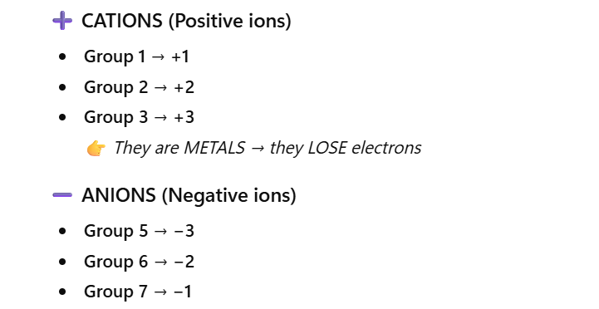

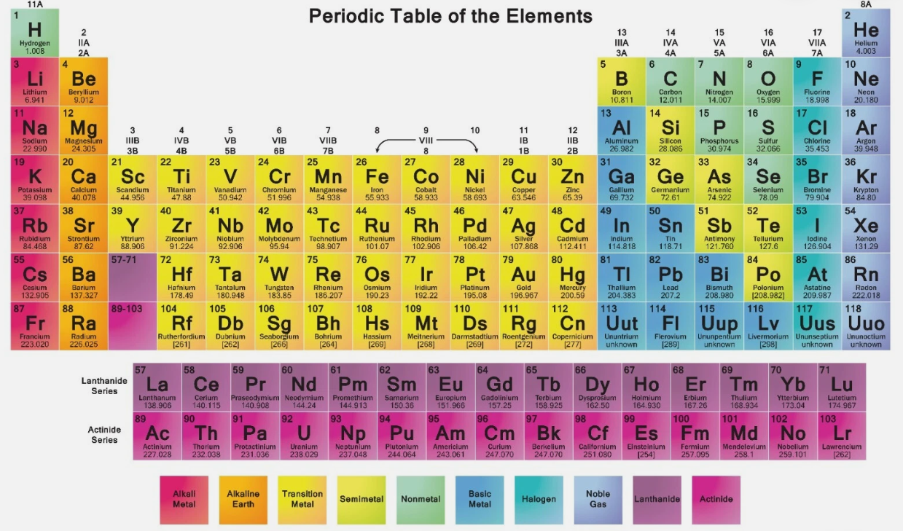

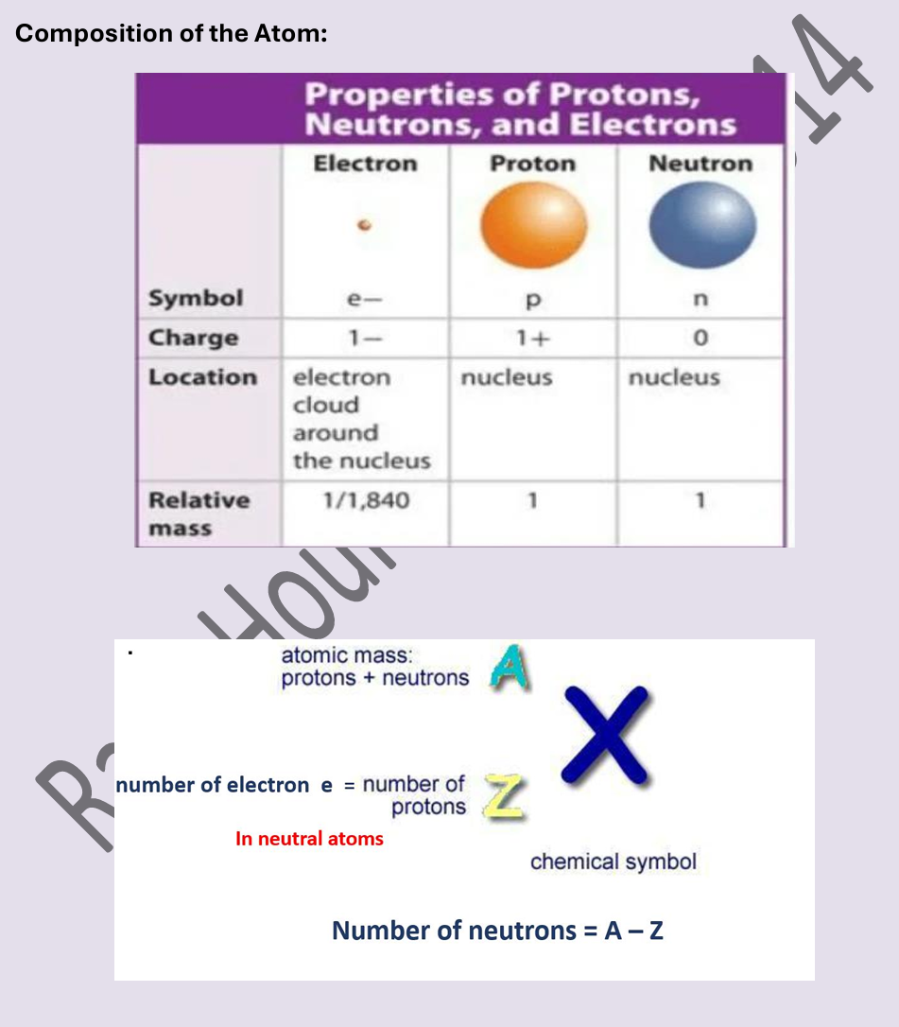

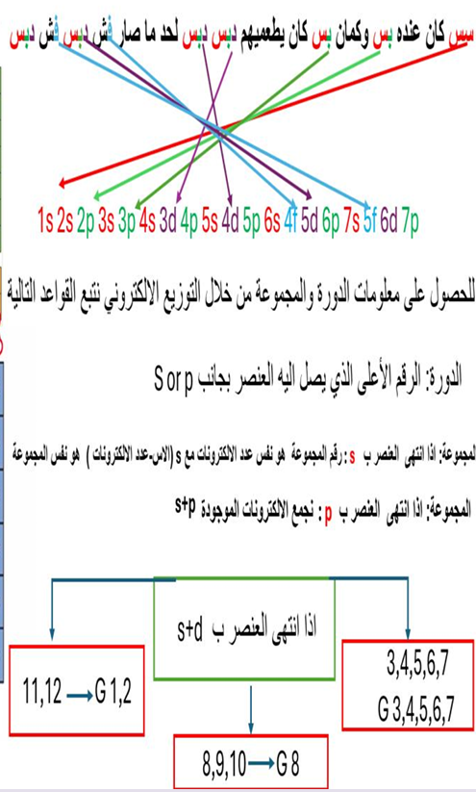

1. Which statement BEST defines an isotope?
A. Atoms with different numbers of protons
B. Atoms with different atomic numbers
C. Atoms with the same number of protons but different numbers of neutrons
D. Atoms with the same mass number
Answer: C

2. All isotopes of the same element have the same:
A. Mass number
B. Number of neutrons
C. Atomic mass
D. Number of protons
Answer: D

3. What determines the identity of an element?
A. Number of neutrons
B. Atomic mass
C. Number of protons
D. Electron configuration
Answer: C

4. The atomic number (Z) of an element represents the number of:
A. Neutrons
B. Protons
C. Electrons + neutrons
D. Mass units
Answer: B

5. How is the modern periodic table arranged?
A. Increasing atomic mass
B. Alphabetical order
C. Increasing atomic number
D. Increasing neutron number
Answer: C

6. Elements in the same group have similar:
A. Atomic masses
B. Numbers of neutrons
C. Chemical properties
D. Period numbers
Answer: C

7. Which particle contributes MOST to atomic mass?
A. Electron
B. Proton
C. Neutrino
D. Photon
Answer: B

8. The mass number (A) of an atom equals:
A. Protons − neutrons
B. Protons + electrons
C. Protons + neutrons
D. Neutrons − electrons
Answer: C

9. An element has atomic number 17 and mass number 35. How many neutrons does it have?
A. 17
B. 18
C. 35
D. 52
Answer: B

10. Which of the following is a compound?
A. Air
B. CO₂
C. Saltwater
D. Brass
Answer: B

11. CO₂ is classified as a compound because:
A. It is a mixture of gases
B. It contains carbon only
C. It has elements chemically bonded in fixed ratios
D. It can be separated physically
Answer: C

12. Which of the following is a mixture?
A. CO₂
B. NaCl
C. H₂O
D. Air
Answer: D

13. A mixture is BEST described as:
A. A substance with a fixed chemical formula
B. Elements chemically bonded
C. A physical combination of substances
D. A pure substance
Answer: C

14. Which statement about compounds is TRUE?
A. They can be separated physically
B. They have variable composition
C. They consist of elements chemically bonded
D. They retain properties of their components
Answer: C

15. Which of the following is NOT a mixture?

A. Air
B. CO₂
C. Seawater
D. Soil
Answer: B

🔢 Atomic Mass & Weighted Average

16. Atomic mass on the periodic table represents:
A. Mass of the most common isotope
B. Mass of one atom
C. Weighted average of isotopes
D. Mass number
Answer: C

17. What is the first step in calculating atomic mass from isotopes?
A. Add isotope masses
B. Convert % abundance to fraction
C. Subtract atomic numbers
D. Multiply atomic number by mass
Answer: B

18. Fractional abundance is obtained by:
A. % × 100
B. % ÷ 100
C. Mass ÷ 100
D. Mass × 100
Answer: B

19. Chlorine has two isotopes: 75% Cl-35 and 25% Cl-37. Which setup is correct?
A. (35 + 37) ÷ 2
B. (0.75 × 35) + (0.25 × 37)
C. (75 × 35) + (25 × 37)
D. (35 − 37) ÷ 2
Answer: B

20. If an element has only one isotope, its atomic mass equals:
A. 0
B. Average of all elements
C. The mass of that isotope
D. The atomic number
Answer: C

21. An element has isotopes of mass 10 amu (20%) and 11 amu (80%). What is the atomic mass?
A. 10.2 amu
B. 10.5 amu
C. 10.8 amu
D. 11.0 amu
Answer: C

22. Which isotope contributes MOST to atomic mass?
A. The heaviest isotope
B. The lightest isotope
C. The most abundant isotope
D. All equally
Answer: C

23. Why is atomic mass usually NOT a whole number?
A. Atoms are unstable
B. Neutrons vary
C. It is a weighted average of isotopes
D. Electrons affect mass
Answer: C

24. Gallium has two isotopes: Ga-69 (60%) and Ga-71 (40%). Which is closer to atomic mass?
A. 69
B. 70
C. 71
D. 72
Answer: B

25. If isotope A is more abundant, the atomic mass will be:
A. Closer to isotope A
B. Exactly between isotopes
C. Equal to isotope B
D. Independent of abundance
Answer: A

🧬 Isotopes & Periodic Table Concepts

26. Isotopes differ in the number of:
A. Protons
B. Electrons
C. Neutrons
D. Atomic numbers
Answer: C

27. Which isotope notation is correct?
A. ¹²₆C
B. C₆¹²
C. ₁₂C₆
D. 6C¹²
Answer: A

28. The periodic law states that:
A. Atomic mass increases periodically
B. Properties repeat when elements are arranged by atomic number
C. Elements are random
D. All groups behave the same
Answer: B

29. Elements in the same period have the same:
A. Number of protons
B. Number of shells
C. Chemical properties
D. Charges
Answer: B

30. Which group forms −1 ions?
A. Group 1
B. Group 2
C. Group 7
D. Group 8
Answer: C
35. Which particle determines the atomic number of an element?
A. Neutron
B. Electron
C. Proton
D. Nucleus
Answer: C

36. Which particle has almost negligible mass?
A. Proton
B. Neutron
C. Electron
D. Alpha particle
Answer: C

37. Atoms of the same element MUST have the same:
A. Number of neutrons
B. Mass number
C. Atomic number
D. Atomic mass
Answer: C

38. Which pair represents isotopes of the same element?
A. ¹²₆C and ¹⁴₇N
B. ³⁵₁₇Cl and ³⁷₁₇Cl
C. ²³₁₁Na and ²⁴₁₂Mg
D. ¹⁶₈O and ¹⁶₇N
Answer: B

39. The periodic table is arranged in order of increasing:
A. Atomic mass
B. Neutron number
C. Atomic number
D. Mass number
Answer: C

40. Elements in the same group have the same number of:
A. Protons
B. Neutrons
C. Energy levels
D. Valence electrons
Answer: D

41. Elements in the same period have the same number of:
A. Valence electrons
B. Protons
C. Energy levels
D. Neutrons
Answer: C

42. Which of the following is a noble gas?
A. Oxygen
B. Chlorine
C. Neon
D. Sodium
Answer: C

43. Which group of elements usually forms −1 ions?
A. Group 1
B. Group 2
C. Group 7
D. Group 8
Answer: C

44. Metals usually form ions by:
A. Gaining electrons
B. Sharing electrons
C. Losing electrons
D. Gaining protons
Answer: C

45. Nonmetals usually form ions by:
A. Losing electrons
B. Gaining electrons
C. Losing neutrons
D. Sharing protons
Answer: B

46. Which element is most likely to form a +2 ion?
A. Sodium
B. Magnesium
C. Aluminum
D. Chlorine
Answer: B

47. Which group typically forms +3 ions?
A. Group 1
B. Group 2
C. Group 3 (13)
D. Group 7
Answer: C

48. Which group typically forms −2 ions?
A. Group 5
B. Group 6
C. Group 7
D. Group 8
Answer: B

49. Which element is a metalloid?
A. Sodium
B. Silicon
C. Oxygen
D. Neon
Answer: B

50. Which statement BEST describes a compound?
A. Physical combination of substances
B. Chemically bonded elements in fixed ratios
C. Same element with different masses
D. Pure element
Answer: B

51. Which of the following is a mixture?
A. CO₂
B. NaCl
C. H₂O
D. Air
Answer: D

52. Why is CO₂ considered a compound?
A. It is gaseous
B. It contains oxygen
C. It has fixed chemical composition
D. It is found in air
Answer: C

53. Which of the following is NOT a compound?
A. CO₂
B. H₂O
C. NaCl
D. Air
Answer: D

54. Which substance can be separated by physical means?
A. Compound
B. Element
C. Mixture
D. Molecule
Answer: C

55. Atomic mass on the periodic table represents:
A. Mass of the most common isotope
B. Mass number
C. Weighted average of isotopes
D. Total number of particles
Answer: C

56. Why is atomic mass usually not a whole number?
A. Atoms are unstable
B. Electrons add mass
C. It is a weighted average
D. Protons vary
Answer: C

57. What is the first step in calculating atomic mass?
A. Add isotope masses
B. Divide by atomic number
C. Convert % abundance to fraction
D. Subtract neutrons
Answer: C

58. Fractional abundance is calculated by:
A. % × 100
B. % ÷ 100
C. Mass × 100
D. Mass ÷ 100
Answer: B

59. An element has two isotopes: 90% X-10 and 10% X-11. Which isotope contributes more to atomic mass?
A. X-10
B. X-11
C. Both equally
D. Cannot be determined
Answer: A

60. If one isotope is much more abundant, the atomic mass will be:
A. Exactly between isotopes
B. Equal to the heavier isotope
C. Closer to the more abundant isotope
D. Always a whole number
Answer: C

61. Chlorine has isotopes ³⁵Cl (75%) and ³⁷Cl (25%). Which setup is correct?
A. (35 + 37) ÷ 2
B. (0.75 × 35) + (0.25 × 37)
C. (75 × 35) + (25 × 37)
D. (35 − 37) ÷ 2
Answer: B

62. Which isotope notation is correct?
A. ¹²₆C
B. C₆¹²
C. ₁₂C₆
D. 6C¹²
Answer: A

63. An element has atomic number 12. How many protons does it have?
A. 6
B. 12
C. 24
D. Depends on isotope
Answer: B

64. An atom with mass number 23 and atomic number 11 has how many neutrons?
A. 11
B. 12
C. 23
D. 34
Answer: B

65. Which element belongs to Group 1?
A. Magnesium
B. Aluminum
C. Sodium
D. Chlorine
Answer: C

66. Which element belongs to Group 2?
A. Na
B. Mg
C. Al
D. Cl
Answer: B

67. Which element belongs to Group 7?
A. Oxygen
B. Nitrogen
C. Chlorine
D. Neon
Answer: C

68. Which group contains chemically inert elements?
A. Group 1
B. Group 2
C. Group 7
D. Group 8
Answer: D

69. Atomic size generally increases when moving:
A. Left to right
B. Right to left
C. Down a group
D. Across a period
Answer: C

70. Ionization energy generally increases when moving:
A. Down a group
B. Left across a period
C. Right across a period
D. Toward metals
Answer: C

71. Metals are usually found on the:
A. Right side of the periodic table
B. Upper right
C. Left side
D. Zigzag line
Answer: C

72. Nonmetals are usually found on the:
A. Left side
B. Lower left
C. Right side
D. Center
Answer: C

73. Which element is most likely to gain electrons?
A. Sodium
B. Magnesium
C. Chlorine
D. Aluminum
Answer: C

74. Which element is most likely to lose electrons?
A. Oxygen
B. Chlorine
C. Neon
D. Sodium
Answer: D

75. The zigzag line on the periodic table separates:
A. Metals and gases
B. Periods and groups
C. Metals and nonmetals
D. Alkali metals and halogens
Answer: C

76. Which group has 5 valence electrons?
A. Group 13
B. Group 14
C. Group 15
D. Group 16
Answer: C

77. Which ion is an anion?
A. Na⁺
B. Mg²⁺
C. Cl⁻
D. Al³⁺
Answer: C

78. Which ion is a cation?
A. O²⁻
B. N³⁻
C. Cl⁻
D. Na⁺
Answer: D

79. Which group forms +1 ions?
A. Group 1
B. Group 2
C. Group 6
D. Group 7
Answer: A

80. Which group forms −3 ions?
A. Group 13
B. Group 15
C. Group 16
D. Group 17
Answer: B

81. Which element is a noble gas?
A. Fluorine
B. Oxygen
C. Neon
D. Nitrogen
Answer: C

82. Which substance has a fixed chemical formula?
A. Air
B. Soil
C. CO₂
D. Seawater
Answer: C

83. Which of the following is a pure substance?
A. Air
B. Brass
C. CO₂
D. Saltwater
Answer: C

84. What happens to metallic character down a group?
A. Decreases
B. Increases
C. Stays constant
D. Becomes zero
Answer: B

85. What happens to metallic character across a period?
A. Increases
B. Decreases
C. Stays constant
D. Random
Answer: B

86. Which element is least reactive?
A. Sodium
B. Chlorine
C. Neon
D. Magnesium
Answer: C

87. Which of the following is NOT an isotope property?
A. Same atomic number
B. Same element
C. Different neutrons
D. Different chemical behavior
Answer: D

88. Which particle determines chemical properties?
A. Neutrons
B. Valence electrons
C. Protons
D. Nucleus
Answer: B

89. Which group contains halogens?
A. Group 1
B. Group 2
C. Group 7
D. Group 8
Answer: C

90. Which element is in Period 3?
A. Helium
B. Neon
C. Sodium
D. Carbon
Answer: C

91. Which element has two energy levels?
A. Sodium
B. Magnesium
C. Neon
D. Aluminum
Answer: C

92. Which element has three valence electrons?
A. Na
B. Mg
C. Al
D. Cl
Answer: C

93. Which element has six valence electrons?
A. Nitrogen
B. Oxygen
C. Fluorine
D. Neon
Answer: B

94. Which element is in Group 18?
A. Chlorine
B. Oxygen
C. Neon
D. Nitrogen
Answer: C

95. Why do noble gases rarely form ions?
A. They are heavy
B. They have complete valence shells
C. They have no neutrons
D. They are synthetic
Answer: B

96. Which of the following is ALWAYS a compound?
A. Air
B. CO₂
C. Brass
D. Seawater
Answer: B

97. Which property distinguishes a compound from a mixture?
A. Color
B. Physical state
C. Fixed composition
D. Size
Answer: C

98. Which statement about isotopes is FALSE?
A. They have different masses
B. They have different atomic numbers
C. They have different neutrons
D. They belong to the same element
Answer: B

99. The atomic mass of an element depends MOST on:
A. Atomic number
B. Number of neutrons
C. Isotope abundance
D. Electron mass
Answer: C

100. Why is CO₂ NOT a mixture?
A. It is gaseous
B. It contains oxygen
C. It has chemically bonded elements in fixed ratios
D. It is found in air
Answer: C
1. An element has the electron configuration: 1s² 2s² 2p⁶. In which group and period is this element located?
A. Group 1, Period 2
B. Group 18, Period 2
C. Group 2, Period 3
D. Group 17, Period 2
Answer: B
(Neon → noble gas, Period 2)

2. The electron configuration 1s² 2s² 2p⁶ 3s¹ belongs to an element in:
A. Group 1, Period 3
B. Group 2, Period 3
C. Group 13, Period 3
D. Group 1, Period 2
Answer: A
(Sodium → one valence electron, third shell)

3. An element has the electron configuration 1s² 2s² 2p⁶ 3s². What is its group and period?
A. Group 1, Period 3
B. Group 2, Period 2
C. Group 2, Period 3
D. Group 12, Period 3
Answer: C
(Magnesium → Group 2, Period 3)

4. Which electron configuration corresponds to a Group 17 element in Period 3?
A. 1s² 2s² 2p⁵
B. 1s² 2s² 2p⁶ 3s² 3p⁵
C. 1s² 2s² 2p⁶ 3s¹
D. 1s² 2s² 2p⁶ 3s² 3p⁶
Answer: B
(Chlorine → halogen, Period 3)

5. An element is in Period 2 and Group 13. Which electron configuration is correct?
A. 1s² 2s²
B. 1s² 2s² 2p¹
C. 1s² 2s² 2p³
D. 1s² 2s² 2p⁶
Answer: B
(Boron → Group 13)

6. The period number of an element is determined by:
A. Number of valence electrons
B. Total number of electrons
C. Highest principal energy level (n) occupied
D. Number of protons
Answer: C

7. The group number (main-group elements) is determined by:
A. Total number of shells
B. Number of valence electrons
C. Number of neutrons
D. Atomic mass
Answer: B

8. An element has the electron configuration 1s² 2s² 2p⁶ 3s² 3p³. Identify its group and period.
A. Group 15, Period 3
B. Group 13, Period 3
C. Group 5, Period 2
D. Group 16, Period 3
Answer: A
(Phosphorus → 5 valence electrons)

9. Which electron configuration represents an element in Group 18?
A. 1s² 2s²
B. 1s² 2s² 2p⁴
C. 1s² 2s² 2p⁶
D. 1s² 2s² 2p⁵
Answer: C
(Noble gas configuration)

10. An element has 3 energy levels and 6 valence electrons. Which group and period does it belong to?
A. Group 6, Period 2
B. Group 16, Period 3
C. Group 15, Period 3
D. Group 16, Period 2
Answer: B

